# Project structure

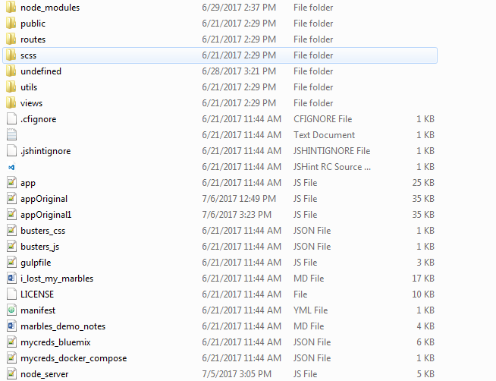

# RUNNING THE APPLICATION

1. Open the docker application from the project directory/folder.
2. Clone the fabric using the following command

***git clone https://github.com/IBM-Blockchain/fabric-images.git***

1. It should create a fabric image folder in the project directory.

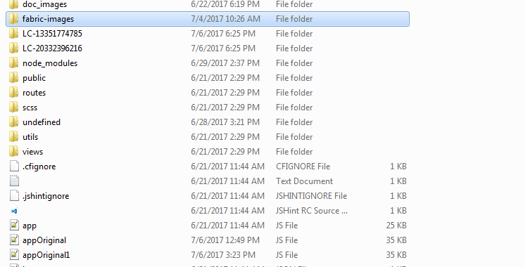

1. Go inside docker-compose

***cd fabric-images/docker-compose***

1. Run the following

***. setenv.sh***

1. Run the four peers using the following command

***docker-compose -f four-peer-ca.yaml up***

1. Open a new terminal or git bash and run the docker prompt by using

***docker exec -it dockercompose_vp0_1 bash***

prefix ***winpty*** with the above command if found error.

1. Create a folder called lc(***mkdir lc***)

Now exit from there typing **exit**

1. Nowgo inside the chaincode folder and run the following command

* ***cd chaincode***
* ***docker cp ./lc.go dockercompose_vp0_1:/opt/gopath/src/github.com/hyperledger/fabric/lc***

1. Now go inside the peer container typing ***docker exec -it dockercompose_vp0_1 bash*** and go inside the **lc** folder to find **lc.go** file.
2. Here build the file using ***go build*** command.(cd .. to /opt/gopath and

***go get github.com/go-sql-driver/mysql*** *)*

1. It should have two files **lc** and **lc.go** file now.

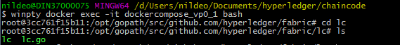

Follow the steps from 7-12 for another peer say ***dockercompose_vp1_1*** inplace of ***dockercompose_vp0_1***

# Deploying the chaincode and running the application

Open postman and create a **post** request <http://192.168.99.100:7050/registrar>

{

"enrollId": "bob",

"enrollSecret": "NOE63pEQbL25"

}



It should show

Open postman and create a **post** request [**http://192.168.99.100:7050/chaincode**](http://192.168.99.100:7050/chaincode)

{

"jsonrpc": "2.0",

"method": "deploy",

"params": {

"type": 1,

"chaincodeID":{

"name": "mycc",

"path": "github.com/hyperledger/fabric/lc"

},

"ctorMsg": {

"function":"init",

"args":[""]

},

"secureContext": "bob"

},

"id": 1

}

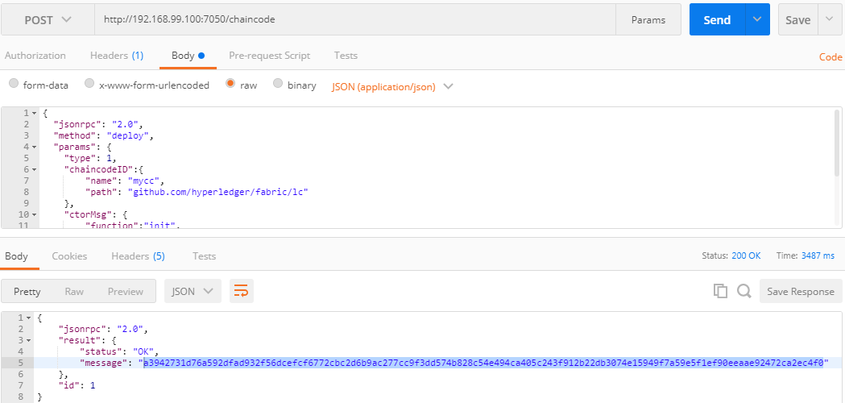

Copy the chaincode and paste in the appOriginal.js and appOriginal1.js files.

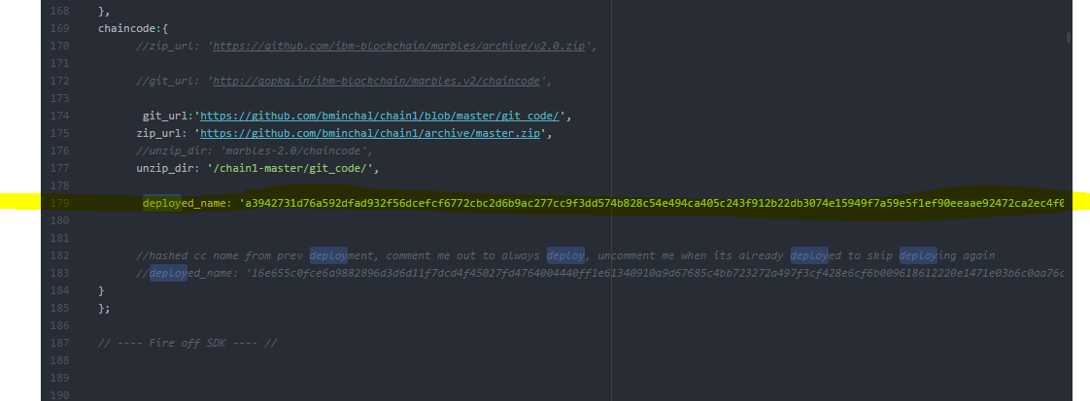

1. Open four terminals/command prompt from inside the project directory. In one terminal run the following commands one by one.

npm install

npm install serve-favicon

npm install mysql

npm install -g maildev --save

npm install express-fileupload

npm install -g maildev –save

# Then run ***appOriginal.js, appOriginal1.js, node_server.js*** and ***maildev***

Using following commands run ***node appOriginal.js, node appOriginal.js, node node_server.js, maildev*** in separate terminals

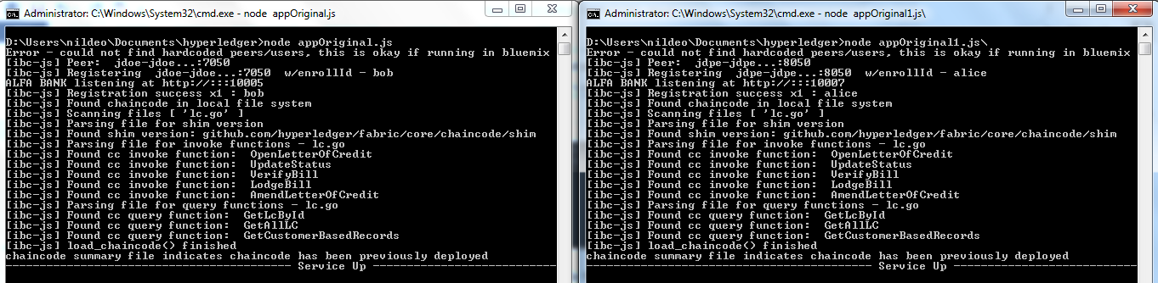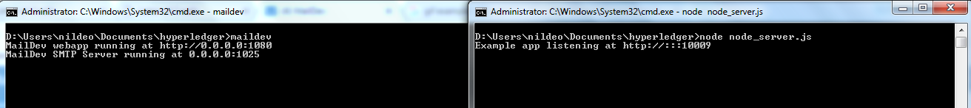

Start in the browser with the following address

